*ASSAM*

*BREIF INFOMATION*

**Assam** is a state in [northeastern](https://en.wikipedia.org/wiki/Northeast_India) [India](https://en.wikipedia.org/wiki/India), south of the eastern [Himalayas](https://en.wikipedia.org/wiki/Himalayas) along the [Brahmaputra](https://en.wikipedia.org/wiki/Brahmaputra_Valley) and [Barak River](https://en.wikipedia.org/wiki/Barak_River) valleys. Assam covers an area of 78,438 km2 . The state is bordered by [Bhutan](https://en.wikipedia.org/wiki/Bhutan) and [Arunachal Pradesh](https://en.wikipedia.org/wiki/Arunachal_Pradesh) to the north; [Nagaland](https://en.wikipedia.org/wiki/Nagaland) and [Manipur](https://en.wikipedia.org/wiki/Manipur) to the east; [Meghalaya](https://en.wikipedia.org/wiki/Meghalaya), [Tripura](https://en.wikipedia.org/wiki/Tripura), [Mizoram](https://en.wikipedia.org/wiki/Mizoram) and [Bangladesh](https://en.wikipedia.org/wiki/Bangladesh) to the south; and [West Bengal](https://en.wikipedia.org/wiki/West_Bengal) to the west via the [Siliguri Corridor](https://en.wikipedia.org/wiki/Siliguri_Corridor), a 22 kilometres (14 mi) wide strip of land that connects the state to the rest of India. It is also one of the world's most populous [subdivisions](https://en.wikipedia.org/wiki/List_of_country_subdivisions_by_population). [Assamese](https://en.wikipedia.org/wiki/Assamese_language) is the official and most commonly spoken language of the state, followed by [Bengali](https://en.wikipedia.org/wiki/Bengali_language), which is official in the [Barak Valley](https://en.wikipedia.org/wiki/Barak_Valley) and [Bodo](https://en.wikipedia.org/wiki/Bodo_language) which is official in [Bodoland Territorial Region](https://en.wikipedia.org/wiki/Bodoland_Territorial_Region)

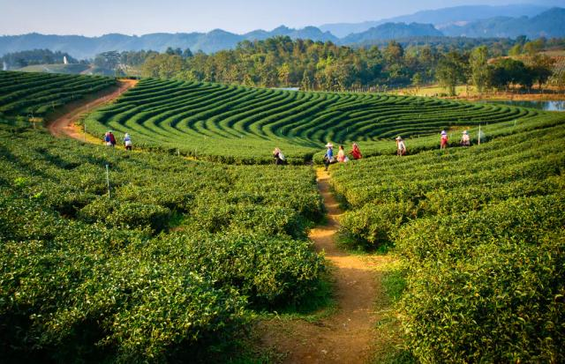

ASSAM ALSO ATTRACTIVE FOR TOURISTS

***GEOGRAPHY***

A significant geographical aspect of Assam is that it contains three of six physiographic divisions of India – The Northern Himalayas (Eastern Hills), The Northern Plains (Brahmaputra plain) and Deccan Plateau (Karbi Anglong). As the Brahmaputra flows in Assam the climate here is cold and there is rainfall most of the month. Geomorphic studies conclude that the Brahmaputra, the life-line of Assam, is an antecedent river older than the Himalayas. The river with steep [gorges](https://en.wikipedia.org/wiki/Canyon) and rapids in Arunachal Pradesh entering Assam, becomes a [braided river](https://en.wikipedia.org/wiki/Braided_river) (at times 10 mi/16 km wide) and with tributaries, creates a flood plain (Brahmaputra Valley: 50–60 mi/80–100 km wide, 600 mi/1000 km long).[[53]](https://en.wikipedia.org/wiki/Assam#cite_note-RLSinghIndia-53) The hills of [Karbi Anglong](https://en.wikipedia.org/wiki/Karbi_Anglong), [North Cachar](https://en.wikipedia.org/wiki/North_Cachar) and those in and close to Guwahati (also Khasi-Garo Hills) now eroded and dissected are originally parts of the South Indian Plateau system.

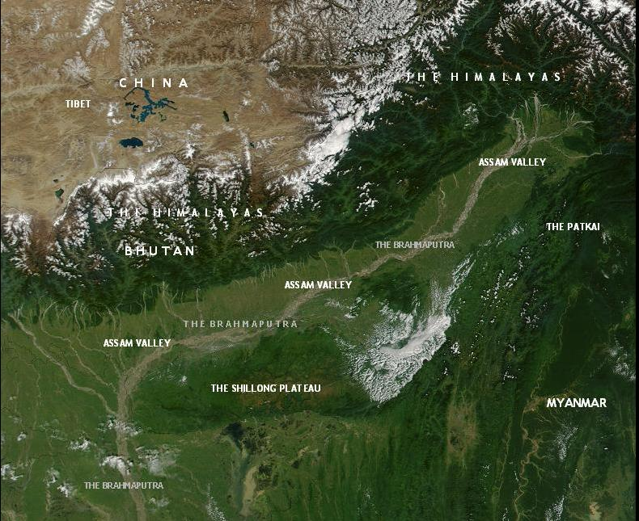

***ASSAM TRADITION***

***DHOTI AND GHAMOSA***

The Dhoti and Gamosa are said to be the native dress of the men of Assam. The Dhoti is used to cover the lower half of the body and is a well-known piece of clothing in other Indian traditions too.

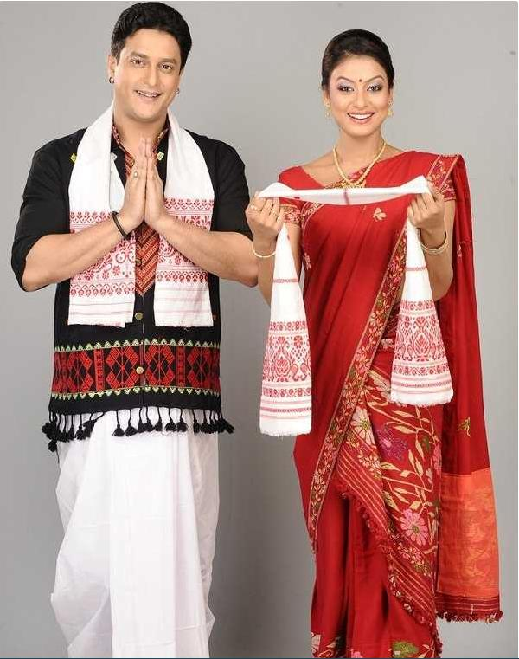

## ***Mekhela Chador - The Traditional Dress of Assam***

***The Mekhela Chador is the traditional dress for the women of Assam. It is worn by women of all ages except children***

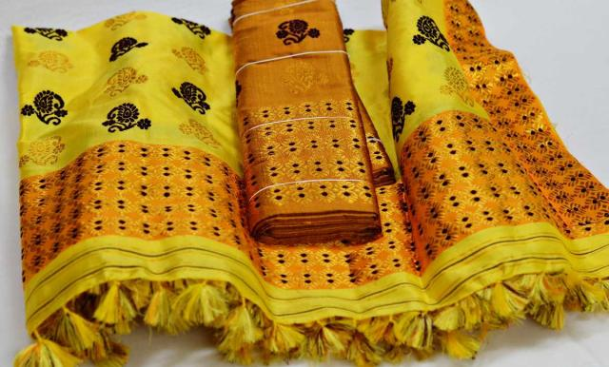

## ***Tribal Wear Of Assam*** The Dimasa Tribe

The men of the Dimasa tribe are known to wear a Sgaopha or a Phagri (a turban) which is a sign of the pride they take in their name.

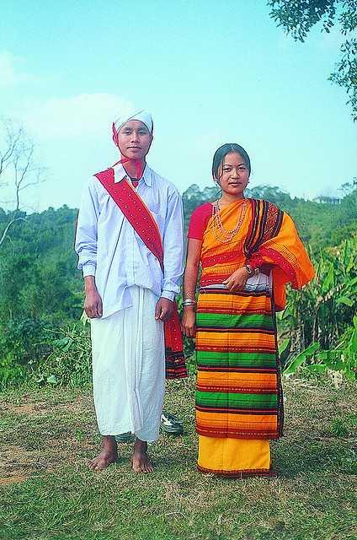

## ***The Bodo Tribe***

The men of the Bodo tribe are simple dressers and can be seen wearing the common dress of Assam i.e. the Gamosa.

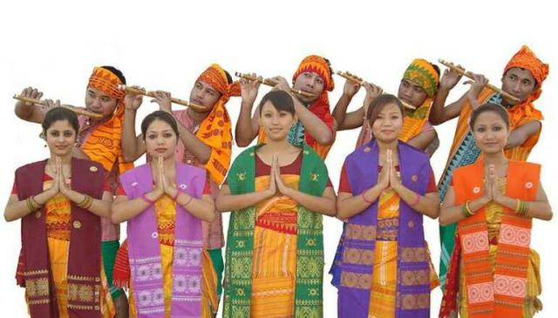

## ***The Mishing Tribe***

The mishing tribe is one of the tribes that follows the code of dressing of Assam as a whole. The men of the tribe wear, what is called a Gonru Ugon which is a Dhoti that is a piece of cloth worn from the waist down. Mibu Galuk is a shirt like a dress that is used by men to cover their upper body. Like other groups, these people also have a great place for the Gamosa Dumer.

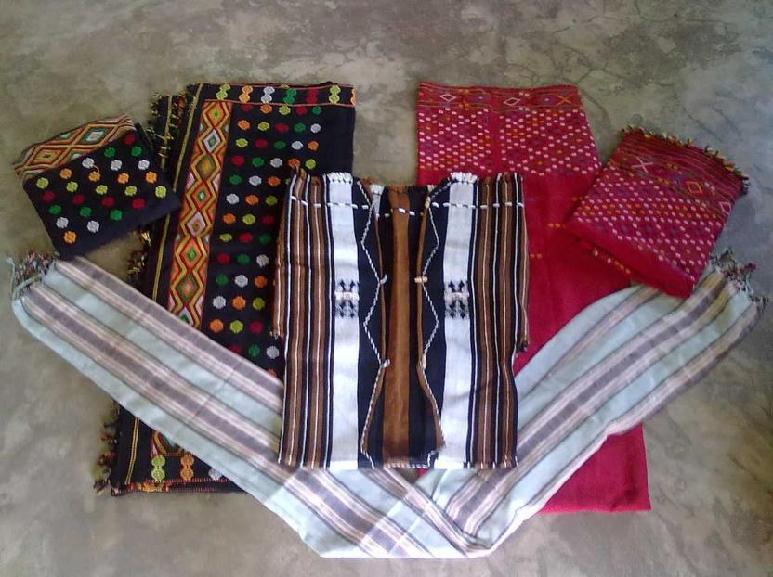

## ***The Rabha Tribe***

The people of the Rabha Tribe are deeply attached to their traditions and have a unique sense of dressing when it comes to the women of the tribe. The men, however, follow the common Assamese dressing code of Dhoti and Gamosa. Though the people are doing some alterations in the same, they seem to like the native way of dressing in white ( or colourful) dhoti and the long Gamosa that is one constant in almost every tribe in the state.

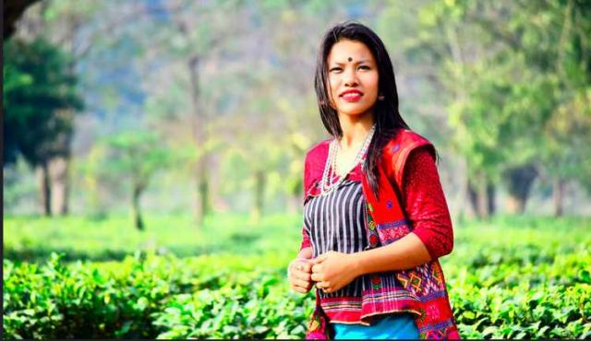

***POPULATION***

### **Population**

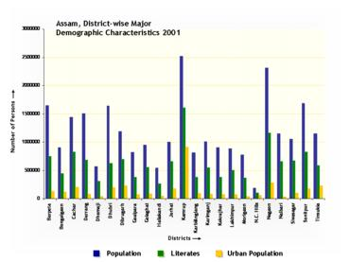

District-wise Demographic Characteristics in 2001

|  |  |  |  |
| --- | --- | --- | --- |
| show**Population Growth** | | | |

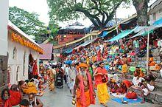

People gathered at [Kamakhya Temple](https://en.wikipedia.org/wiki/Kamakhya_Temple) for the [Ambubachi Mela](https://en.wikipedia.org/wiki/Ambubachi_Mela)

The total population of Assam was 26.66 million with 4.91 million households in 2001. Higher population concentration was recorded in the districts of [Kamrup](https://en.wikipedia.org/wiki/Kamrup_district), [Nagaon](https://en.wikipedia.org/wiki/Nagaon_district), [Sonitpur](https://en.wikipedia.org/wiki/Sonitpur_district), [Barpeta](https://en.wikipedia.org/wiki/Barpeta_district), [Dhubri](https://en.wikipedia.org/wiki/Dhubri_district), [Darrang](https://en.wikipedia.org/wiki/Darrang_district), and [Cachar](https://en.wikipedia.org/wiki/Cachar_district). Assam's population was estimated at 28.67 million in 2006 and at 30.57 million in 2011 and is expected to reach 34.18 million by 2021 and 35.60 million by 2026.

### **Religions**

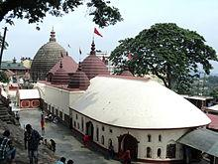

[Kamakhya Temple](https://en.wikipedia.org/wiki/Kamakhya_Temple)

Religion in Assam (2011)[84

[Hinduism](https://en.wikipedia.org/wiki/Hinduism) (61.47%)

[Islam](https://en.wikipedia.org/wiki/Islam) (34.22%)

[Christianity](https://en.wikipedia.org/wiki/Christianity) (3.74%)

[Buddhism](https://en.wikipedia.org/wiki/Buddhism) (0.18%)

[Jainism](https://en.wikipedia.org/wiki/Jainism) (0.08%)

[Sikhism](https://en.wikipedia.org/wiki/Sikhism) (0.07%)

[Animism](https://en.wikipedia.org/wiki/Animism) (0.09%)

Other or not religious (0.16%)

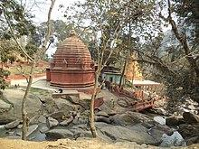

[Basistha Temple](https://en.wikipedia.org/wiki/Basistha_Temple) in [Guwahati](https://en.wikipedia.org/wiki/Guwahati).

According to the [2011 census](https://en.wikipedia.org/wiki/2011_Census_of_India), 61.47% were [Hindus](https://en.wikipedia.org/wiki/Hinduism), 34.22% were [Muslims](https://en.wikipedia.org/wiki/Muslim).[[84]](https://en.wikipedia.org/wiki/Assam#cite_note-census2011-84)[[85]](https://en.wikipedia.org/wiki/Assam#cite_note-85) Christian minorities (3.7%) are found among the Scheduled Tribe and Castes population.[[86]](https://en.wikipedia.org/wiki/Assam#cite_note-86) The Scheduled Tribe population in Assam is around 13%, of which Bodos account for 40%.[[87]](https://en.wikipedia.org/wiki/Assam#cite_note-87) Other religions followed include [Jainism](https://en.wikipedia.org/wiki/Jainism) (0.1%), [Buddhism](https://en.wikipedia.org/wiki/Buddhism) (0.2%), [Sikhism](https://en.wikipedia.org/wiki/Sikhism) (0.1%) and [Animism](https://en.wikipedia.org/wiki/Animism) (amongst [Khamti](https://en.wikipedia.org/wiki/Khamti_people), [Phake](https://en.wikipedia.org/wiki/Tai_Phake_people), [Aiton](https://en.wikipedia.org/wiki/Tai_Aiton_people) etc. communities). Many Hindus in Assam are followers of the [Ekasarana Dharma](https://en.wikipedia.org/wiki/Ekasarana_Dharma) sect of [Hinduism](https://en.wikipedia.org/wiki/Hinduism), which gave rise to [Namghar](https://en.wikipedia.org/wiki/Namghar), designed to be simpler places of worship than traditional Hindu temples

***LANGUAGE***

[***Assamese***](https://en.wikipedia.org/wiki/Assamese_language) ***is the official language of the state. Additional official languages include*** [***Bengali***](https://en.wikipedia.org/wiki/Bengali_language) ***and*** [***Bodo***](https://en.wikipedia.org/wiki/Bodo_language) ***languages. Bodo in*** [***Bodoland Territorial Council***](https://en.wikipedia.org/wiki/Bodoland_Territorial_Council) ***and*** [***Bengali***](https://en.wikipedia.org/wiki/Bengali_language) ***in the three districts of*** [***Barak Valley***](https://en.wikipedia.org/wiki/Barak_Valley) ***where*** [***Sylheti***](https://en.wikipedia.org/wiki/Sylheti_language) ***is most commonly spoken.***

## ***Government and politics***

Assam has Governor [Jagdish Mukhi](https://en.wikipedia.org/wiki/Jagdish_Mukhi) as the head of the state,[[2]](https://en.wikipedia.org/wiki/Assam#cite_note-nie-Mukhi-2) the [unicameral](https://en.wikipedia.org/wiki/Unicameral) [Assam Legislative Assembly](https://en.wikipedia.org/wiki/Assam_Legislative_Assembly) of 126 members, and a government led by the [Chief Minister of Assam](https://en.wikipedia.org/wiki/List_of_Chief_Ministers_of_Assam). The state is divided into five regional [divisions](https://en.wikipedia.org/wiki/Divisions_of_Assam).

On 19 May 2016, [BJP](https://en.wikipedia.org/wiki/BJP) under the leadership of [Sarbananda Sonowal](https://en.wikipedia.org/wiki/Sarbananda_Sonowal) won the Assembly elections, thus forming the first BJP-led government in Assam

## Economy

Assam's economy is based on agriculture and oil. Assam produces more than half of India's tea.[[152]](https://en.wikipedia.org/wiki/Assam#cite_note-152) The Assam-Arakan basin holds about a quarter of the country's oil reserves, and produces about 12% of its total petroleum.[[153]](https://en.wikipedia.org/wiki/Assam#cite_note-153) According to the recent estimates,[[154]](https://en.wikipedia.org/wiki/Assam#cite_note-government2005-154) Assam's per capita GDP is [₹](https://en.wikipedia.org/wiki/Indian_rupee)6,157 at constant prices (1993–94) and [₹](https://en.wikipedia.org/wiki/Indian_rupee)10,198 at current prices; almost 40% lower than that in India.[[155]](https://en.wikipedia.org/wiki/Assam#cite_note-155) According to the recent estimates,[[154]](https://en.wikipedia.org/wiki/Assam#cite_note-government2005-154) per capita income in Assam has reached [₹](https://en.wikipedia.org/wiki/Indian_rupee)6756 (1993–94 constant prices) in 2004–05, which is still much lower than India's.